High quality and large area colloidal photonic crystal films coated on flexible sheets

H. Fudouzi*
National Institute for Materials Science, 1-2-1 Sengen, Tsukuba, Ibaraki, 305-0047, Japan
* Corresponding author: fudouzi.hiroshi@nims.go.jp

Please, use the British or the US English for preparation of the text of the abstract. Its length should not exceed one A4 page including all the text, graphics and references. The abstract should include (i) main objective(s) of the presented work (ii) one graphics which will highlighting your research at glance or show its most significant result(s) (iii) conclusions made on the results and (iv) outlines of ongoing research and/or its applications.
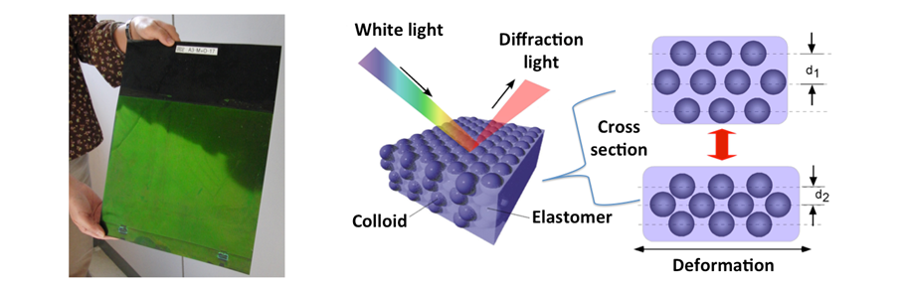
Fig. 1. Large area colloidal photonic crystal films deposited on flexible PET substrate.

REFERENCES
1. H. Fudouzi, Opal photonic crystal films with tunable structural colour, in Responsive photonic nanostructures: Smart nanoscale optical materials (Ed. Y. Yin), RSC Publishing, 2013, pp. 44-62.
2. H. Fudouzi, Colloidal Photonic Crystal Films: Fabrication and Tunable Structural Color and Applications in: Nanomaterials and Nanoarchitectures (Eds. M. Bardosova, T. Wagner), Springer, 2015, pp. 1–19.
3. H. Fudouzi, T. Sawada, Photonic rubber sheets with tunable color by elastic deformation, Langmuir 22, 1365–1368 (2006).
4. H. Fudouzi, T. Sawada, Y. Tanaka, I. Ario, T. Hyakutake, I. Nishizaki, Smart photonic coating as a new visualization technique of strain deformation of metal plates, Proc. of SPIE 8345, 1–7 (2012).

